|  |
| --- |
|  |
| PowerPoint Templates to create - list  **With CAST Comments and Status**  Report Generator |
|  |
|  |
| **Magdalena Gałkiewicz** |
| **2013-08-14** |

**Table Templates**

**C:\_ATA_CAST\21. CAST AIP PS Tools\Resources_png\png\32x32\accept.png**

**Field no 4:**

**Type = TABLE**

**Modules List** 🡪 Block Name = **MODULES LIST**  
 🡪 Options : *none*

*Description: List, in form of table, names of all application modules listed on the ADG Dashboard*

**CAST 🡪 Comment and delivery**

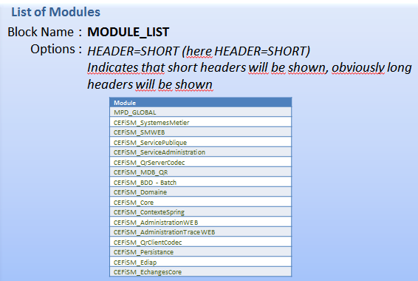

*C:\_ATA_CAST\21. CAST AIP PS Tools\Resources_png\png\32x32\accept.png*

**Filed no 5:**

**Type = TABLE**

**TQI** 🡪 Block Name = **TQI**  
 🡪 Options : *none*

*Description: Should show, in form of table, TQI for current and previous version*

*( if first snapshot “-“ should be put for the previous version)*

*Ex.:*

*Wycinek ekranu*

**CAST 🡪 Comment and delivery**

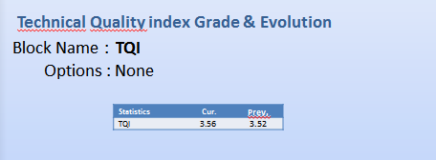

*C:\_ATA_CAST\21. CAST AIP PS Tools\Resources_png\png\32x32\accept.png*

**Field no 6:**

**Type = TABLE**

**Technical Size Information** 🡪 Block Name = **TECHNICAL\_SIZING** 🡪 Options : *none*

*Description: Should show kLOCs, number of Files, Classes, SQL Art. And Tables in the entire application for current and previous version*

*( if first snapshot “-“ should be put for the previous version)*

*Ex.:*

*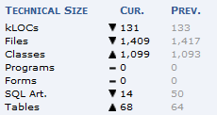*

(A similar field is already created (Block Name = **TECHNICAL\_SIZING)** but there is information about previous version missing).

**CAST 🡪 Comment and delivery**

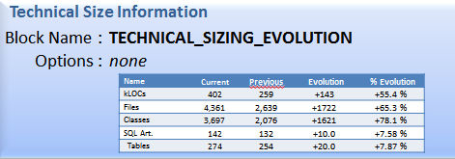

*C:\_ATA_CAST\21. CAST AIP PS Tools\Resources_png\png\32x32\accept.png***Field no 11:**

**Type=TABLE**

**Modules TQI // Modules TQI-comparison** 🡪 Block Name = **MODULS\_TQI //MODULS\_TQI\_COMPARISON** 🡪 Options : *none*

*Description: Should list, in form of table, names of all application modules, the TQI grade for current and previous version for each module, delta of TQI for each module.*

*Ex.:*

*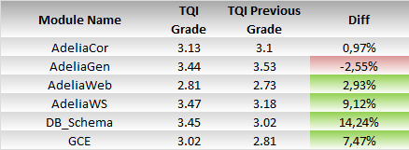*

**CAST 🡪 Comment and delivery**

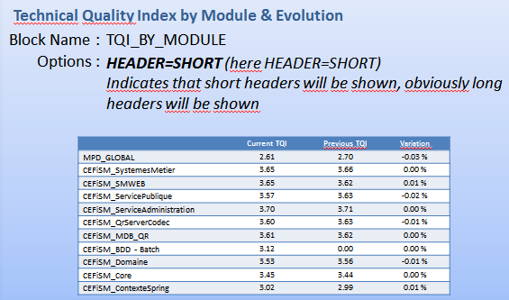

****Field no 13:**

**Type=TABLE**

**Modules -Technology LoC** 🡪 Block Name = **MODULS\_TECHNOLOGY\_LOC** 🡪 Options : *COUNT=N (here COUNT is null)*

*COUNT=M(here COUNT is 6)*

*where N is the shown technology count (if null, default value = 5)*

*and M is the shown modules count (if null, default value = 5)*

*Description: Should list, in form of table, names of all application modules and LOC of each technology used in the application for each module*

*Ex.*

*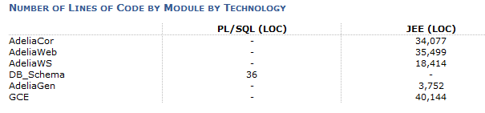*

**CAST 🡪 Comment and delivery**

*The component is not implemented yet*

**

**Field no 15:**

**Type=TABLE**

**Complexity Distribution** 🡪 Block Name = **COMPLEXITY\_DISTRIBUTION** 🡪 Options : *none*

*Description: Should list, in form of table, CC Distribution categories and the number of artifacts categorized in according to their CC. Additionally should* shows the location of the Critical Violations - i.e. whether they are in Low, Average, High or Very High complexity code.

*Ex.:*

*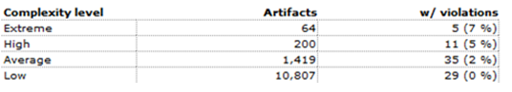*

**CAST 🡪 Comment and delivery**

*The component exists, but all values are at 0 when executed on a AIP 7.0.18.*

**

**Field no 17:**

**Type=TABLE**

**CCompliance to objectives - entire application & latest delivery** 🡪 Block Name = **COMPLIANCE\_TO\_OBJECTIVES\_EntireApplication\_LastDelivery** 🡪 Options : *none*

*Description: Should show, in form of table, number of violated and all applicable critical metrics in the current snapshot for* ***only new and modified code*** *and for the entire* ***Application****.*

*Ex.:*

**

**CAST 🡪 Comment and delivery**

*The component is under design; results are not accurate enough to be delivered.*

**

**Field no 18:**

**Type=TABLE**

**VC by Module (Total, Added, Removed)**🡪 Block Name = **VC\_BY\_MODULE (Total, Added, Removed)**

🡪 Options : *COUNT=N (here COUNT is null)*

*where N is the shown technology count (if null, default value = 5)*

*Description: Should list, in form of table, number of Critical Violations (Total, Added and Removed) for the five main Business Criteria for each Module in the parent Application.*

*Ex.:*

*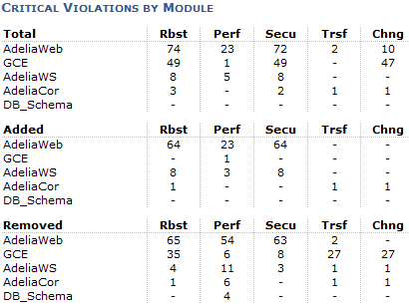*

**CAST 🡪 Comment and delivery**

*The component is under design; results are avaibale only for the “Total” section.*

*The sections “Added” and “Removed” are not available yet.*

C:\_ATA_CAST\21. CAST AIP PS Tools\Resources_png\png\32x32\accept.png

**Field no 19:**

**Type=TABLE**

**Statistics on Violations**

🡪 Block Name = **VIOLATION\_STATISTICS** 🡪 Options : none

*Description: Should show, in form of table, statistics for Critical Violations: Number of Critical violation per file and per kLOC, Complex Objects (w/ Violations) for current and previous version*

*( if first snapshot “-“ should be put for the previous version)*

*Ex.:*

*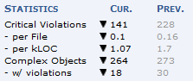*

(A similar field is already created (Block Name = **VIOLATION\_STATISTICS)** but there is information about previous version missing).

**CAST 🡪 Designed Field**

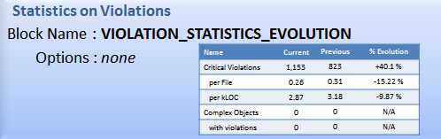

*C:\_ATA_CAST\21. CAST AIP PS Tools\Resources_png\png\32x32\accept.png*

**Field no 20:**

**Type=TABLE**

**Technical Debt** 🡪 Block Name = **TECHNICAL\_DEBT**  🡪 Options : *none*

*Description: Should show, in form of table, total Technical Debt per application, Technical Debt added in current release of the application and Technical Debt removed in current release of the application*

*Ex.:*

*Wycinek ekranu*

**CAST 🡪 Comment and delivery**

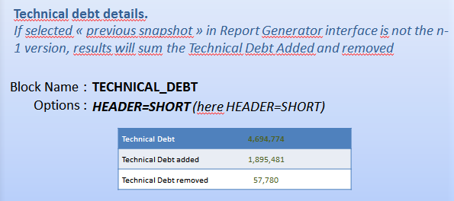

*C:\_ATA_CAST\21. CAST AIP PS Tools\Resources_png\png\32x32\accept.png***GRAPH TEMPLATES**

**Field no 12:**

**Type=GRAPH**

**Distribution of Modules by number of artifacts**

🡪 Block Name = **MODULS\_ARTIFACTS** 🡪 Options : *COUNT=N (here COUNT is 10)*

*where N is the shown modules count (if null, default value = 5)*

*Description: Should show, in form of graph, application modules taking into account the number of artifacts.*

*Ex.:*

*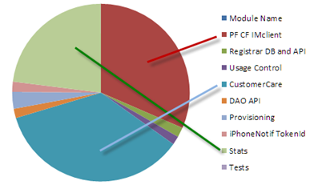*

**CAST 🡪 Comment and delivery**

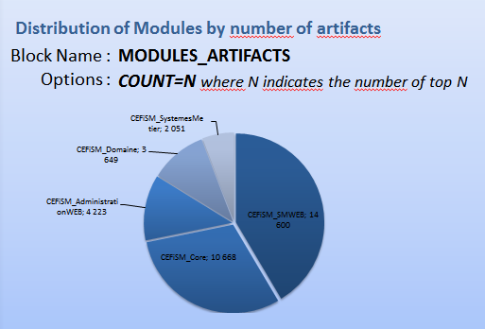

****Field no 16:**

**Type=GRAPH**

**Compliance to objectives - entire application & latest delivery** 🡪 Block Name = **COMPLIANCE\_TO\_OBJECTIVES\_EntireApplication\_LastDelivery** 🡪 Options : *none*

*Description: Should show, in form of graph, number of violated and all applicable critical metrics in the current snapshot for* ***only new and modified code*** *and for the entire* ***Application****.*

*Ex.:*

*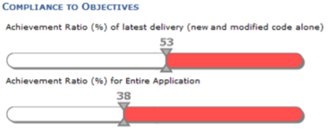*

**CAST 🡪 Comment and delivery**

*The component is not available*